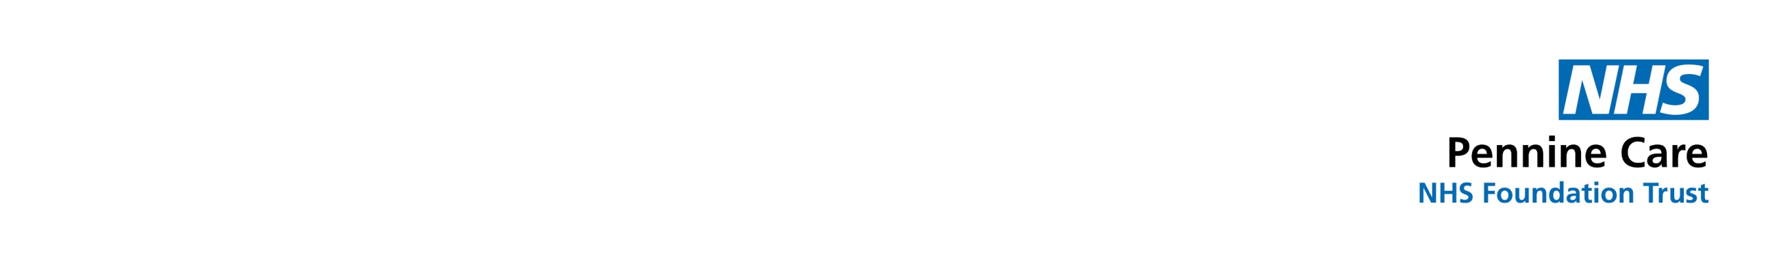

Insert the name of your report here

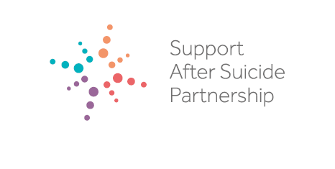



Insert the name of your report here



**Shared Learning:**

**Bereavement by Suicide**

**‘From Grief to Hope’**

**Introduction – ‘From Grief to Hope’**

**Each person lost to suicide is a personal tragedy. It is estimated that 800,000 die by suicide globally each year with approximately 6,500 people taking their life in the UK in 2018. Suicide occurs across all ages, genders and ethnic groups.**

**Between September 2017 and August 2018 over 7,150 people across the UK completed an online survey about their experience of being bereaved or affected by suicide.**

**Currently, our knowledge and understanding of effective postvention support is limited. It is important to have a better understanding of what people find helpful in coping with their grief whilst recognising that there is no single approach that will meet the needs of each person who has lost someone to suicide.**

**The study looked at the impact suicide had on these individuals both at a personal and professional level.**

**The study also looked at the experience of accessing support services and if it was considered helpful.**

**The aims of the study were to:**

* **Identify the impact a death by suicide has on those who are bereaved or affected by suicide.**
* **Identify the level of contact / support individuals receive from health professionals when bereaved by suicide.**
* **Explore how support for people bereaved or affected by suicide can be improved.**

**2. High Risk behaviours**

**8% of respondents reported self harm and 38% had considered taking their own lives, of these 8% had made an attempt.**

**Other risk behaviours including substance misuse, irresponsible financial behaviour, sexual promiscuity and a lack of road safety were reported in 1/5 of people.**

**Behaviours persisted 12 months after the loss.**

**1. The Impact of Suicide**

**A major or moderate impact was reported in 82% of respondents.**

**A number of people experienced relationship break ups, unemployment and financial problems.**

**1/5 of people reported deteriorating physical health.**

**Over 1/3 reported mental health problems (particularly common in women)**

**3. Relationship to the deceased**

**A range of adverse life events were reported, these varied depending on the relationship to the deceased.**

**Most common was the loss of a friend and participants who had lost friends were more likely to have experienced multiple suicides.**

**Those who lost friends often reported ‘hidden grief’, isolation and being overlooked by services.**

**4. Accessing support**

**60% did not access support & 1/3 did not know what support was available**

**1/3 accessed support from family & friends and did not feel they needed additional help.**

**Those who did access support did so from a range of public, private and 3rd sector services.**

**62% perceived provision of local suicide bereavement support to be inadequate**

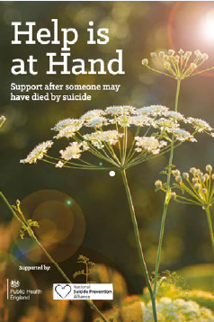

**5. Support Requested**

**Respondents reported that immediate proactive support was important and that whilst some were not ready to receive support at this time, they said that information should be available and accessible (such as ‘Help is at Hand’ booklet) or details of a contact person.**

**After initial contact respondents reported that specialist suicide bereavement support should be available, with follow up at 3, 6, 12 or 18 months after the suicide occurred.**

* **A national online resource for those bereaved or affected by suicide**
* **Campaign to raise awareness of the impact of suicide bereavement**
* **Suicide bereavement training for all front line staff**
* **Support for people with risk taking behaviours**
* **Workplace suicide bereavement support**
* **Further research on the impact of suicide**

**Recommendations**

**Suicide prevention and more recently postvention support has increasingly become a government priority in the UK. This report supports those priorities to ensure there is consistent quality of suicide bereavement support available and a universal targeted approach to its access and delivery.**

* **The implementation of national minimum standards in postvention services**

**Impact of suicide**

**Suicide has a devastating and long lasting impact on families and communities. The findings of this study illustrate the serious adverse consequences that impact on all aspects of a person’s life after a suicide, from physical and mental health to workplace problems and financial wellbeing. The findings add to the growing evidence base explaining the impact that suicide has on the psychological health of those bereaved.**

**Risk taking behaviours following suicide**

**A range of high risk behaviours are reported in the study. Previous research has shown adolescents exposed to peer suicidal behaviour engaged in substance misuse, physical fights and aggression. This study found consistent themes in the adult population. It also found that these people were more likely to exhibit such behaviour more than a year after the death, suggesting the length of time since the suicide did not lessen the impact of the grief.**

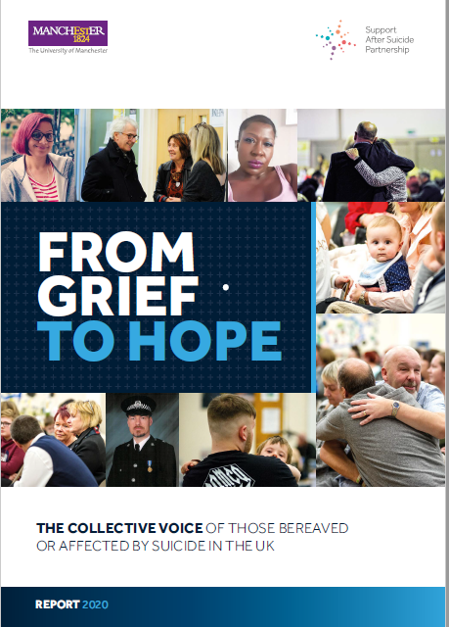

Please click on the following link to download a copy <https://suicidebereavementuk.com/>

**Relationship to the deceased**

**A close relationship to the deceased has been associated with a higher risk of poor mental health outcomes including depression, anxiety, PTSD and prolonged grief.**

**Non – familial connections are important and closeness should not be perceived on the basis of kinship but on the basis of psychological closenessThose who experienced the death of a friend felt overlooked and neglected, this highlights the importance of services being open and accessible to non-family members.**

**Please click on the following link to download a copy** <https://suicidebereavementuk.com/>

**NICE (2019) Suicide Prevention Quality Standard.**

[https://www.nice.org.uk/guidance/qs189/chapter/](C:\\Users\\philc\\AppData\\Local\\Packages\\microsoft.windowscommunicationsapps_8wekyb3d8bbwe\\LocalState\\Files\\S0\\1554\\Attachments\\NICE (2019) Suicide Prevention Quality Standard)

[Quality-statement-5-Supporting-people-bereaved-](C:\\Users\\philc\\AppData\\Local\\Packages\\microsoft.windowscommunicationsapps_8wekyb3d8bbwe\\LocalState\\Files\\S0\\1554\\Attachments\\NICE (2019) Suicide Prevention Quality Standard)

[or-affected-by-a-suspected-suicide](C:\\Users\\philc\\AppData\\Local\\Packages\\microsoft.windowscommunicationsapps_8wekyb3d8bbwe\\LocalState\\Files\\S0\\1554\\Attachments\\NICE (2019) Suicide Prevention Quality Standard)

**Help and Support**

www.samaritans.org

**PAPYRUS Prevention of Young Suicide**

www.papyrus-uk.org

Helpline 0800 068 4141

Monday-Friday 9.00am to 10.00pm

Weekends and Bank Holidays 2.00pm to 10.00pm

SMS: 07860 039 967

[Email: pat@papyrus-uk.org](Email:%20pat@papyrus-uk.org)

**Samaritans**

www.samaritans.org

Helpline 116 123 Everyday, 24 hours

SMS: 07725 909 090

Welsh language line: 0808 164 0123

[Email: jo@samaritans.org](Email:%20jo@samaritans.org)

Helpline 116 123 Everyday, 24 hours



SMS: 07725 909 090



Welsh language line: 0808 164 0123

Email: [jo@samaritans.org](mailto:jo@samaritans.org)

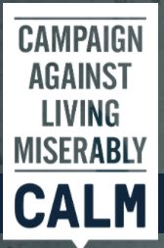

**CALM (campaign against living miserably)**

www.thecalmzone.net

Helpline 0800 58 58 58 / London 080 802 58 58

Open 7 days a week 5.00pm to midnight

Email: info@thecalmzone.net

[Webchat: www.thecalmzone.net/help/webchat/](Webchat:%20www.thecalmzone.net/help/webchat/)

**Survivors of Bereavement by Suicide (SOBS)**

www.uk-sobs.org.uk

Helpline 0300 111 5065

Monday to Friday 9.00am to 9.00pm

[Email: email.support@uksobs.org](Email:%20email.support@uksobs.org)

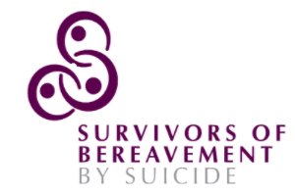

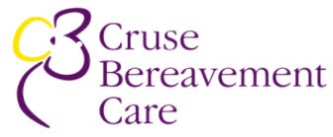

**Cruse Bereavement Care**

www.cruse.org.uk

Helpline 0808 808 1677

Monday to Friday 9.30am to 5pm

Tuesday, Wednesday & Thursday 9.30am to 8pm

Weekends 10am to 2pm

**Winston’s Wish**

www.winstonswish.org

Helpline 08088 020 021

Monday to Friday: 9.00am to 5.00pm

[Email: ask@winstonswish.org](Email:%20ask@winstonswish.org)



**Key resources for people bereaved by suicide**

**Support After Suicide Partnership**

**www.supportaftersuicide.org.uk**

**@AfterSuicideUK**

**Email:** **info@supportaftersuicide.org.uk**

**The Support after Suicide Partnership is a national network of organisations, that**

**support anyone bereaved or affected by suicide. The website provides information,**

**resources and signposting to services. The Partnership also supports NHS England**

**in the implementation of suicide bereavement support services across England, as**

**set out in the NHS Long Term Plan (2019). You can find more information by visiting**

**hub.supportaftersuicide.org.uk**

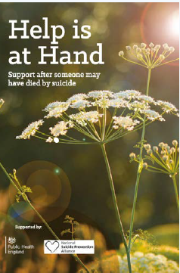

**England – Help is at Hand**

**Produced by the Department of Health, this is a resource for people bereaved**

**by suicide and other sudden, traumatic death in England and Wales. The booklet**

**can be read online at: [www.supportaftersuicide.org.uk/support-guides/helpis-](C:\\Users\\philc\\AppData\\Local\\Packages\\microsoft.windowscommunicationsapps_8wekyb3d8bbwe\\LocalState\\Files\\S0\\1554\\Attachments\\England – Help is at Hand)**

**[at-hand/](C:\\Users\\philc\\AppData\\Local\\Packages\\microsoft.windowscommunicationsapps_8wekyb3d8bbwe\\LocalState\\Files\\S0\\1554\\Attachments\\England – Help is at Hand) or printed copies can be ordered by phoning 0300 123 1002 quoting**

**2901502/Help is at Hand.**

